**Temporal and spatial patterns of decline in Ontario’s hardwood forests**

The Decline Index (DI) and decline severity classes were used to quantify hardwood crown biological responses to cumulative stresses. The DI was a cumulative forest stress state indicator that was developed to quantify visual symptoms of tree crown stress from 0 (no decline) to 100 (maximum decline) (see formula below) (McIlveen *et al.* 1989). Crown dieback was weighted heavier in the DI formula because this metric indicates persistent stress effects, whereas foliage symptoms indicate short-term stress effects. The DI values were divided into incidence classes to indicate decline severity (McLaughlin *et al*. 1992b): Very Low (< 10), Low (10 - <15), Moderate (15 - <20), High (20 - <25) and Severe (≥ 25).

DI = CD + (A * UL) + (A * ST) + (A * SL/2)

Where DI = Decline Index

CD = % Crown Dieback (percent cover of branches with no live foliage in crown)

A = ([100-CD]/400

UL = % Undersized leaves of remnant live foliage

ST = % leaves with strong yellow-pale green chlorosis throughout >75% of a leaf for live foliage

SL = % leaves with slight yellow-pale green chlorosis throughout leaves OR strong yellow-pale green colouration on leaf margins only or <25% of leaf of live foliage

The DI was predictive of other stress/health indicators. Trees were more likely to die in OFBN plots if they had higher DI values in one year and the risk of mortality increased if a tree had higher DI values for two consecutive years (Tominaga *et al*. 2008). Mortality rates could be predicted from 1986 DI values for up to 18 years. Trees with higher DI values in OFBN or nearby sites had lower tree growth rates than trees with lower DI values although the relationship was complex and varied throughout the time record (McLaughlin *et al*. 1992a, Benakoun 2016).

Overall, Ontario hardwood forests have been healthy with plot or regional DI averages per year having numerous very low to low, some moderate, and fewer high or severe decline incidence. Statistical tests were used to confirm the following temporal and spatial DI patterns.

**Temporal Patterns: Intraseasonal**

The standardized DI sampling period removed potential biases of intra-seasonal variation influencing differences across years. The DI was always measured in July-September when leaves were fully developed but not senescent (i.e., dying). Senescent leaves were more likely to have higher chlorosis late in the season when chlorophyll pigment starts to die (Ahmad and Guo 2019). Plot DI means did not get consistently better or worst within each sampling year (Fig. 1, linear regression p = 0.6).

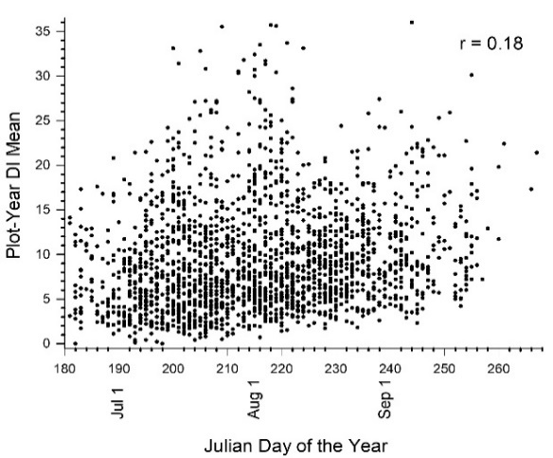

**Fig. 1. Intra-seasonal variation in plot DI means**

**Temporal Patterns: Annual**

Plot DI means and decline incidence differed among years but did not consistently improve or worsen between 1986-2017 (Fig 2). The polynomial regression line shown in Fig 2A demonstrated that decline was higher in the 1980s, decreased in the 1990s, and increased in the 2000s and 2010s. It is unknown whether the recent apparent declining trend may improve in the future as decline has previously worsened and then improved over time. Changes were often increasing (or decreasing) for longer than two years suggesting non-random patterns. The data record was not long enough to show repeating patterns at regular intervals throughout the time series (i.e., periodic). DI changes between two consecutive years explained a significant amount of variation of DI means over the years and was the key driver to forecast annual changes that reflected stresses of the years sampled. Small amounts of residual random variation occurred after the effects of consecutive year trends were removed suggesting that other factors also influenced decline than differences among years.

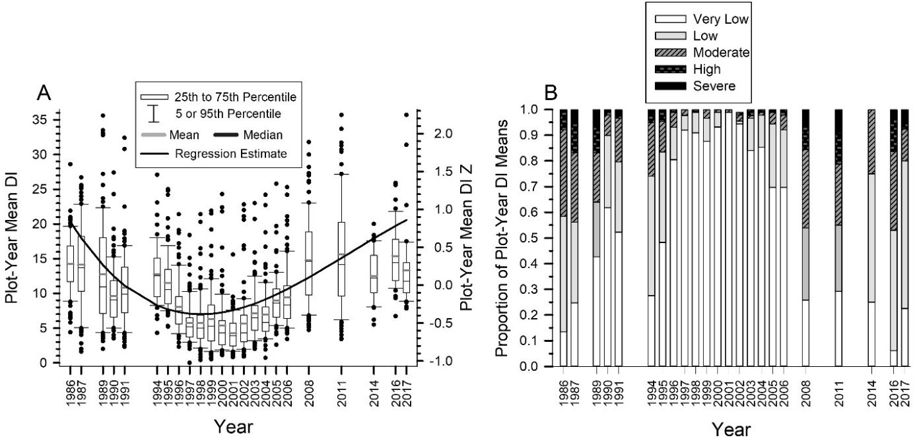

**Fig. 2. Annual changes in DI (A) and incidence (B)**

**Spatial Patterns**

The amount of decline increased as plots were located further north and further east although plot DI means varied considerably, and the west-east trend was less strong (Fig. 3).

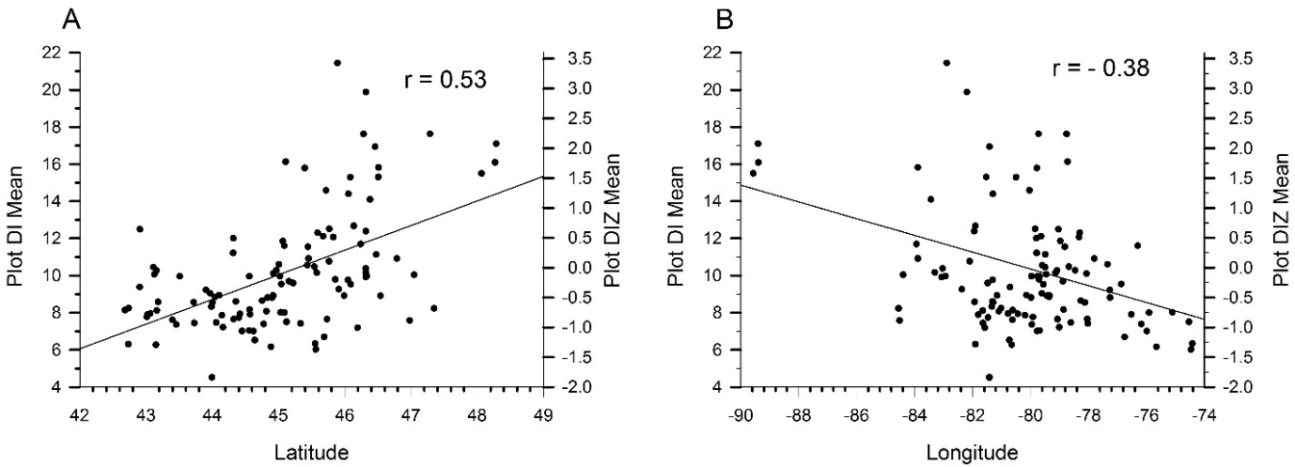

**Fig. 3. DI Latitude and Longitude Trends**

Three forest regional classifications at different spatial scales were compared to determine which one described the decline patterns across the province. The National Ecological Framework’s Ecoregions had the best fit to describe how decline varied throughout the province (Fig. 4). Decline was higher (tree health was poorer) in the Canadian Shield than the Mixed Wood Plain regions likely because forests on the Shield generally have less favourable growing conditions. The Ontario Shield contains Precambrian rock, has cooler temperatures and a shorter growing season, and tends to have acidic and nutrient-poor soils. The Mixedwood Plains has a warmer climate and contains less acidic and nutrient-rich limestone soils. For the non-shield regions, DI was higher in the southwest and lower in the southeast of the province. For the Shield regions, DI was highest in the Thunder Bay region at the northern range of hardwood forests, lower in the mid-north and lowest in the northeast regions in the province.

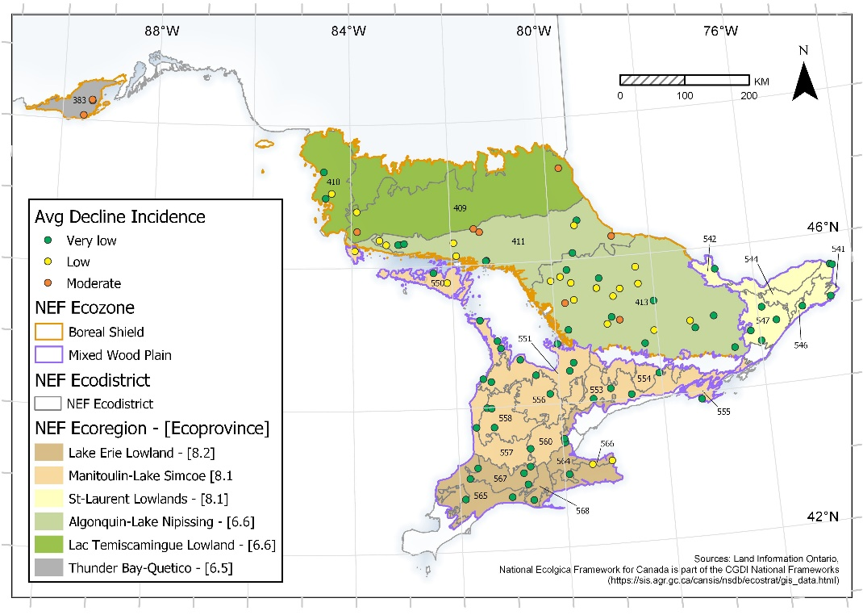

**Fig. 4. Mean plot decline incidence in NEF regions**

**Spatial-temporal DI interactions**

The amount and direction of annual increases or decreases in decline depended on which two consecutive years were compared. These annual increases or decreases did not differ among Ecozones, Ecoregions, Ecodistricts and plots. Thus, the likelihood of decline improving or worsening from one year to the next was similar throughout the province. The NEF Ecoregions had temporally synchronous changes in the DI change from one year to the next i.e., regions had similar responses to annual stresses (Rusak 1999). These results suggest that broad-scaled factors can affect decline across the entire province within the same year. For example, many studies have found that drought can cause higher hardwood forest decline across large areas. Very dry conditions were found in the OFBN plots across Ontario in 2016, and these drought conditions likely resulted in the higher DI values in that year across the province. Thus, time lag responses are important to consider given that regions had similar responses to annual stresses and the DI changes between two consecutive years was able to forecast annual changes throughout the data record.